MAD-1 Project Report:

- Student details:
Name - Niraj kumar ; Roll Number – 23f2005165 ; Smail – 23f2005165@ds.study.iitm.ac.in
I am currently a dual degree student pursuing BS in Data Science from IITM and Bsc in Mathematics from RGU Ramgarh.

- Project Description:
Quiz Master is a web-based multi-user quiz application designed to facilitate engaging and interactive quizzes for users. It allows users to attempt quizzes on various subjects, track scores, and view past performance. The application provides an admin dashboard for managing subjects, chapters, and quizzes efficiently.

- Technologies Stack:
The project is built using Flask (Python), Jinja2, HTML, CSS (Bootstrap), and SQLite as the database.
- Backend: Flask (Python)
- Frontend: HTML, CSS (Bootstrap), Jinja2
- Database: SQLite
- Other Libraries: Flask-SQLAlchemy (ORM), Chart.js (Data visualization)

- Database Schema
User Table:
- userID (Primary Key, Auto-increment, Integer)
- fullname (Not Null, Text)
- username (Unique, Not Null, Text)
- password (Not Null, Text)
- email (Unique, Not Null, Text)
- type (Not Null, Default: 'public', Text)

Subject Table:
- subjectID (Primary Key, Auto-increment, Integer)
- subjectName (Unique, Not Null, Text)
- subjectDescription (Text)

Chapter Table:
- chapterID (Primary Key, Auto-increment, Integer)
- chapterName (Unique, Not Null, Text)
- chapterDescription (Text)
- subjectID (Foreign Key referencing Subject, Not Null, Integer)

Quiz Table:
- quizID (Primary Key, Auto-increment, Integer)
- quizName (Not Null, Text)
- date_of_quiz (Not Null, DateTime)
- duration (Not Null, Integer)
- chapterID (Foreign Key referencing Chapter, Not Null, Integer)

Question Table:
- questionID (Primary Key, Auto-increment, Integer)
- question (Not Null, Text)
- A (Not Null, Text)
- B (Not Null, Text)
- C (Not Null, Text)
- D (Not Null, Text)
- answer (Not Null, Text)
- quizID (Foreign Key referencing Quiz, Not Null, Integer)

Scores Table:
- scoreID (Primary Key, Auto-increment, Integer)
- userID (Foreign Key referencing User, Not Null, Integer)
- quizID (Foreign Key referencing Quiz, Not Null, Integer)
- score (Not Null, Integer)

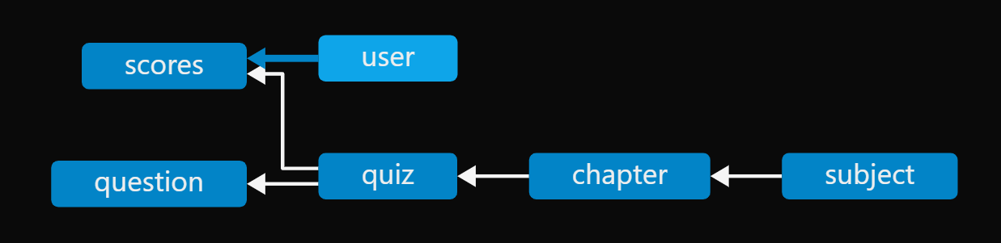

- Features:
User Features:
- User Registration & Login: Secure authentication system.
- Quiz Attempt: Users can attempt quizzes based on available subjects and chapters.
- Result Viewing: Users can check scores and compare past performances.

Admin Features:
- Dashboard Overview: Visual representation of top scores and quiz attempts.
- Quiz Management: Ability to add, edit, and delete quizzes, subjects, and chapters.
- User Management: View registered users.
- Search Functionality: Admin can search for quizzes, subjects, and users.

- Project Demo Video :- https://drive.google.com/file/d/14EviU84leu0hSd4Rp_3z5OvWEF8_F_kC/view?usp=sharing

